**Practical No. 5**

**Aim:** Queries using

1.string functions (Concatenation, lpad, rpad, ltrim, rtrim, lower, upper, initcap, length, substr and instr, ELT(), Char_Length(), Format(), Find_In_Set, Oct(), Reverse(), Repeat(), Ascii())

ii.date functions (Sysdate, next_day, add_months, last_day, months_between, least, greatest, trunc, round, to_char, to_date, PERIOD_DIFF)

iii. numeric functions: Abs (), power (), sqrt (), greatest (), least (), round (), mod ().

iv. time functions (Localtime,Minute(datetime), Microsecond)

**Theory:**

SQL functions such as string, date, numeric, time are predefined operations that can be applied to data in a relational database management system (RDBMS). These functions perform specific tasks on the data and return results. Here's a brief explanation of the usage of SQL functions and how they benefit users

**Queries:**

**1. STRING FUNCTIONS**

1) Concatenation: Concatenates two or more strings together

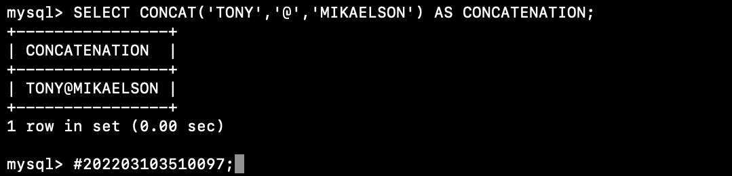

2) Lpad: Helps in padding or adding a string to the left of the given string

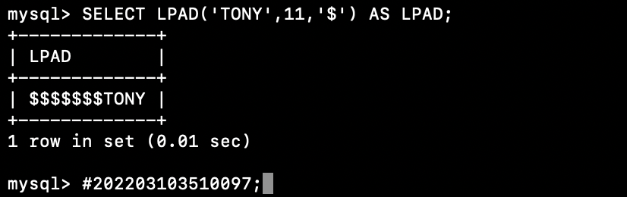

3) Rpad: Helps in padding or adding a string to the right of the given string

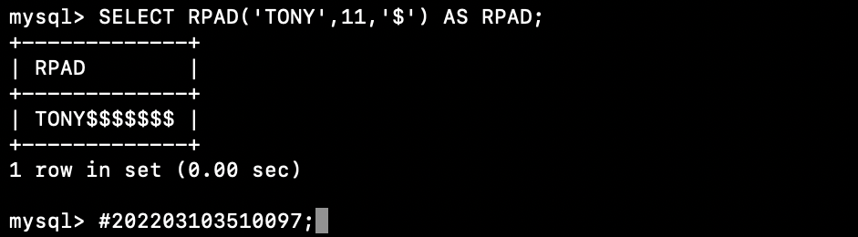

4) Ltrim: Helps to return remove all the space characters found on the lefthand

side of the string

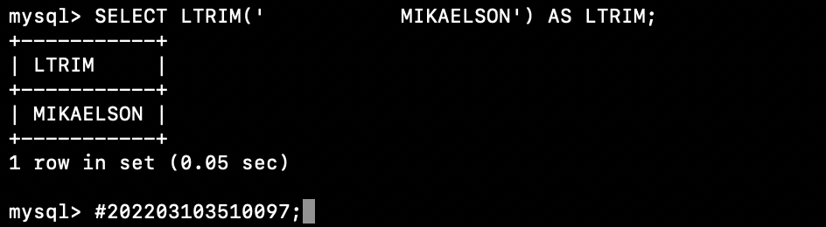

5) Rtrim: Helps to return remove all the space characters found on the righthand

side of the string

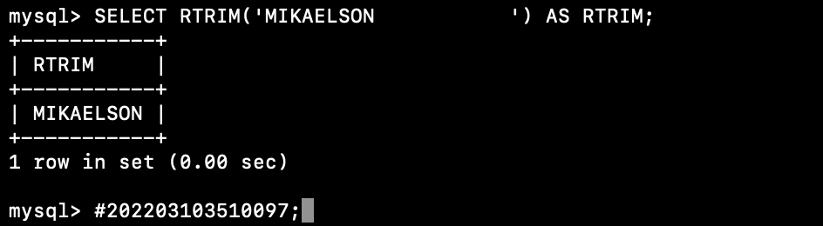

6) Lower: Convert strings to lowercase

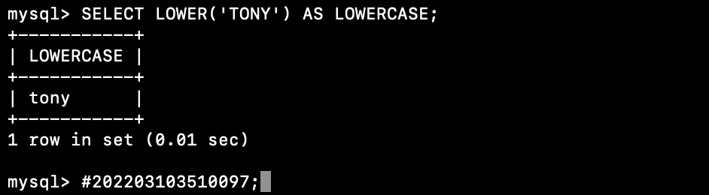

7) Upper: Convert strings to uppercase

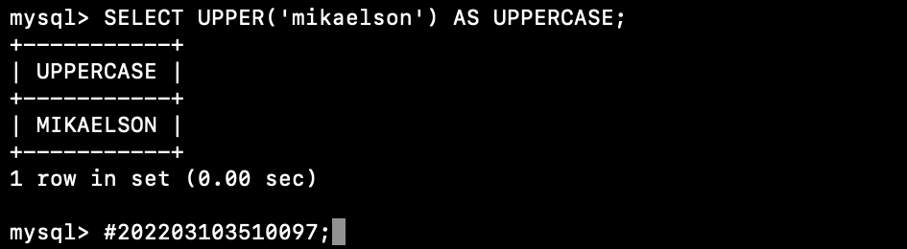

8) Length: Returns the length of a string.

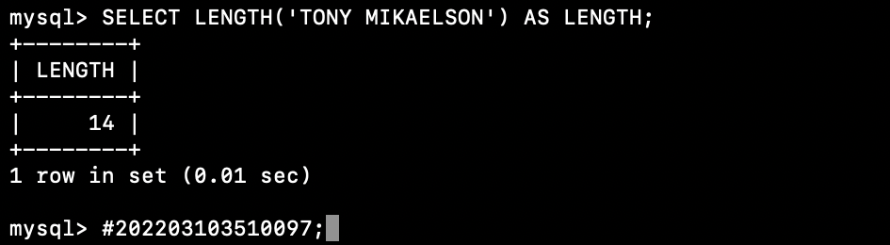

9) Substr: Extracts a portion of a string.

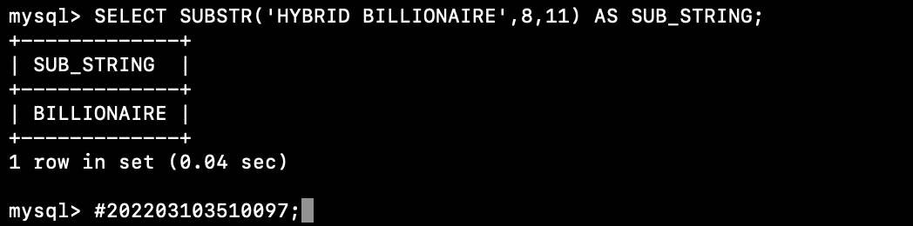

10) Instr: Detects the first occurrence of a string or a character in the other string

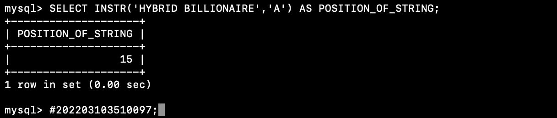

11) Elt: Returns the string from the list of string according to the given index

number

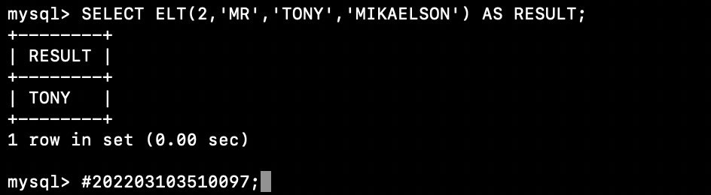

12) Char_Length: Find the length of a given string (in characters)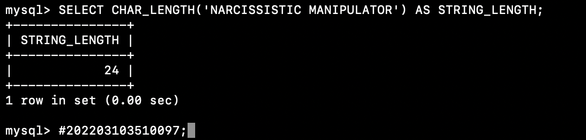

13) Format: Formats a value with the specified format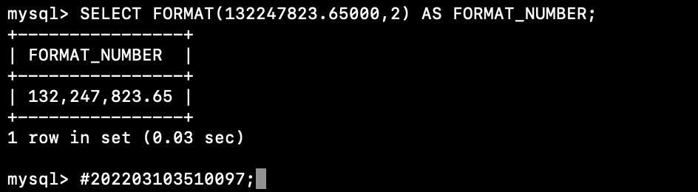

14) Find_In_Set: Allows you to determine the position of a value within a comma -

Separated list

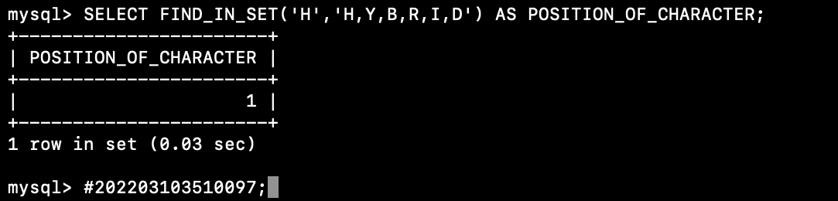

15) Oct: To convert decimal number to octal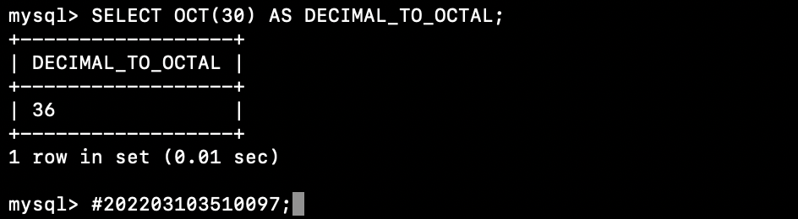

16) Reverse: Reverses a string and returns the result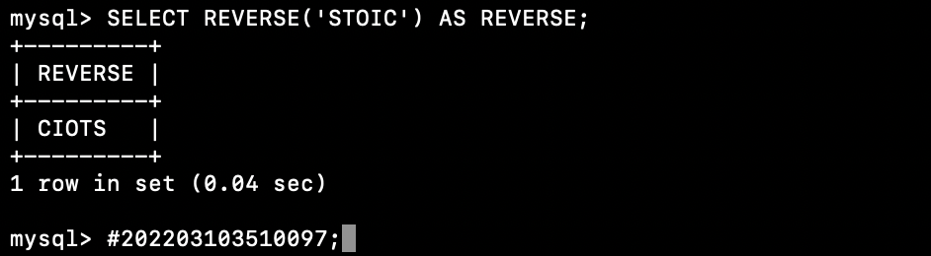

17) Repeat: Repeats a string as many times as specified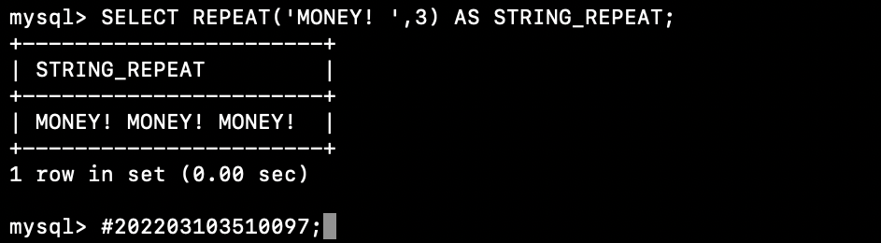

18) Ascii: Returns the ASCII code value of the leftmost character of the specified number or character value

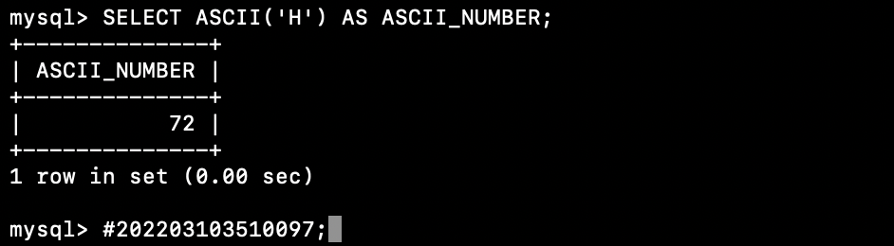

**2. DATE FUNCTIONS**

1) Sysdate: Returns the current date and time

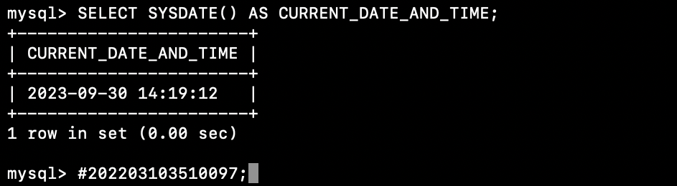

2) Last_day: To know the last day of the month for a given date or a datetime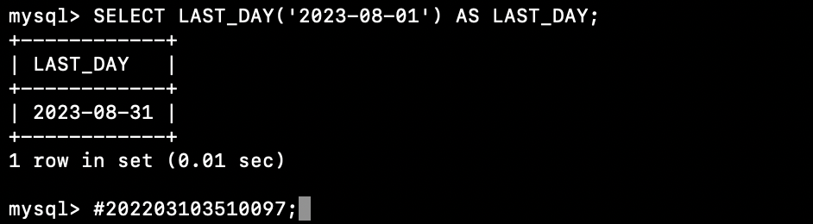

3) To_date: Converts this value to a DATETIME value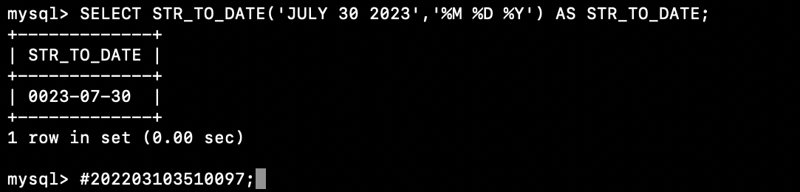

4) Period_diff: Return the difference between two specified periods(YYYY/MM)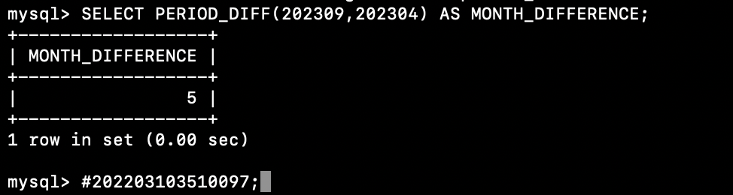

**3. NUMERIC FUNCTIONS**

1) Abs: Return the absolute value of a specified number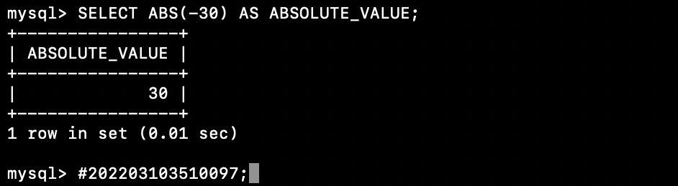

2) Power: Return a results after raising a specified exponent number to a specified

base number

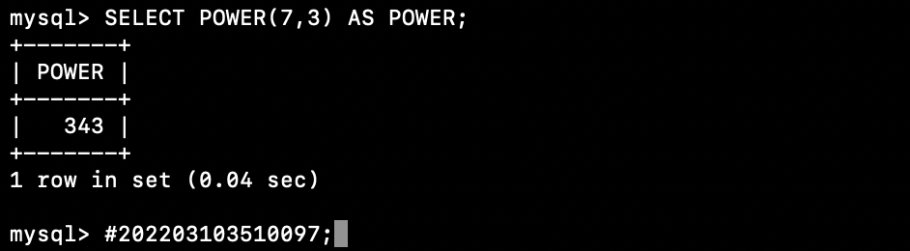

3) Sqrt: Returns the square root of a number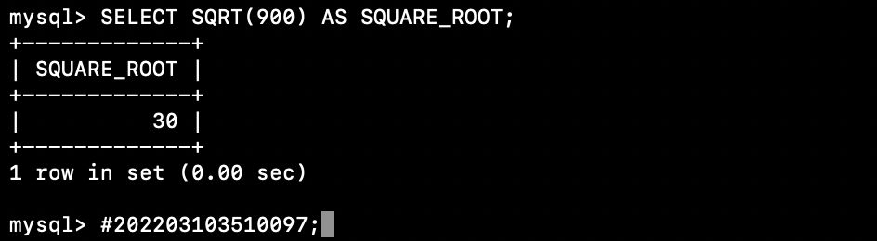

4) Least: Returns the smallest value of the list of arguments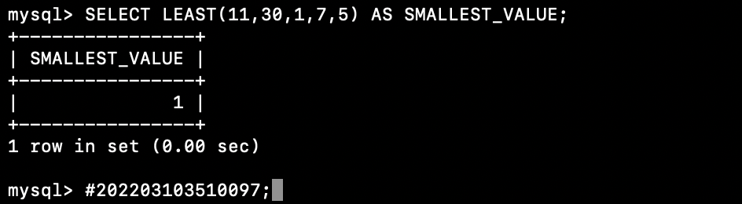

5) Greatest: Returns the greatest value of the list of arguments.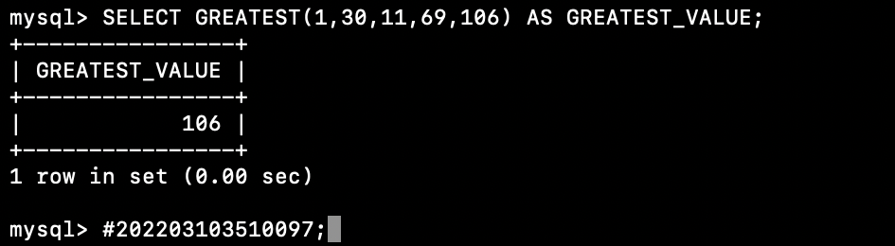

6) Truncate: Return a value that has been truncated (shortened) to a specific number of decimal places

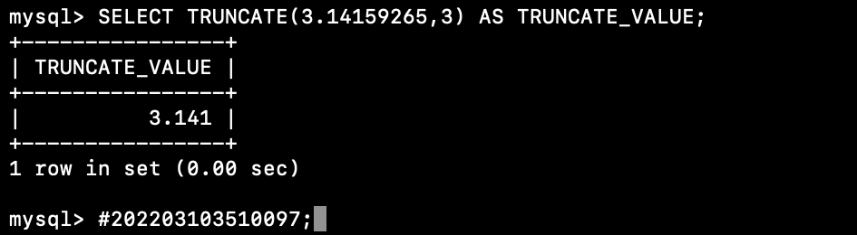

7) Round: Rounds a number to a specified number of decimal places.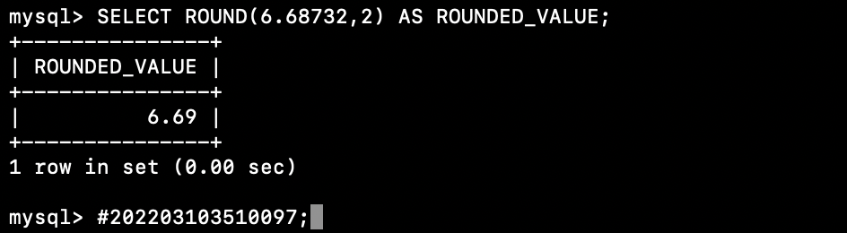

8) Mod: Find the remainder of one number divided by another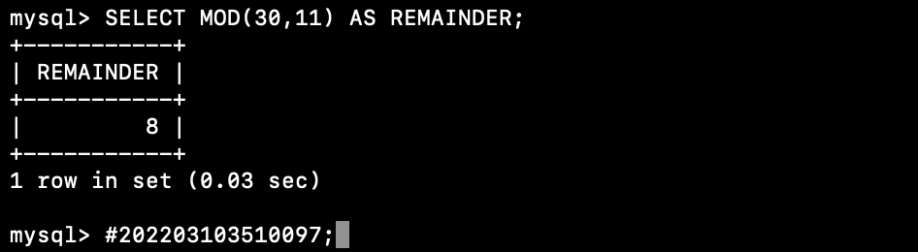

**4. TIME FUNCTIONS**

1) Localtime: Returns the current date and time

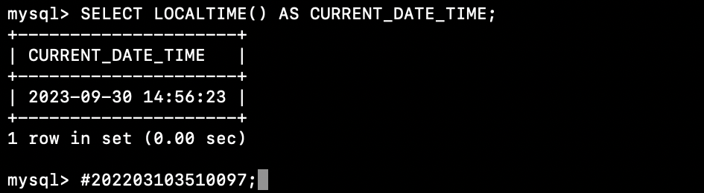

2) Minute: Returns the minute part of a time/datetime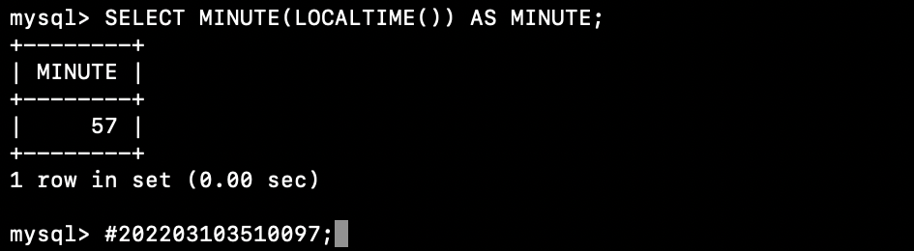

3) Microsecond: Returns the microsecond part of a value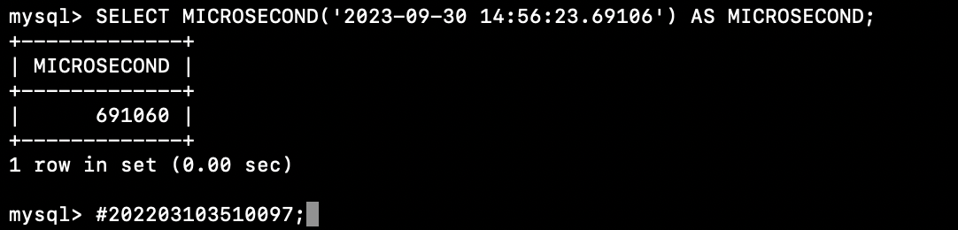

**Conclusion:** These functions are essential for data transformation, cleaning, analysis, and reporting in SQL queries. They enable you to format data for presentation, perform calculations, and extract meaningful insights from your database. Understanding how to use these functions effectively is crucial for SQL data manipulation and reporting tasks.